**Location:** Inner alleys of a Metropolis city – less inhabited part (Urban Alleyway)

**Time:** a snowy winter night, present day

**Story:** Your friend gets on the wrong side of a local city gang and his captured and being held. You get a phone call/note from your friend/gang telling you of your friend’s predicament and it is your job to rescue him.

**Goal:** Rescue your friend from the hands of a gang lord and his henchmen by sneaking through their alleys and/or brute forcing your way through, and then return to the base (police station or home).

**Rescuer (Player):** Friend of person to rescue (most likely male, but not determined yet)

**Person To Rescue:** Friend of Rescuer, got on the bad side of a gang and was captured

**Enemies:**

* Gang members – will attack if they notice you in their base
* Cold – long exposure to cold will decrease your health, lit trash fires around town will keep you warm (Maybe you must find matches in order to light the fires)
* 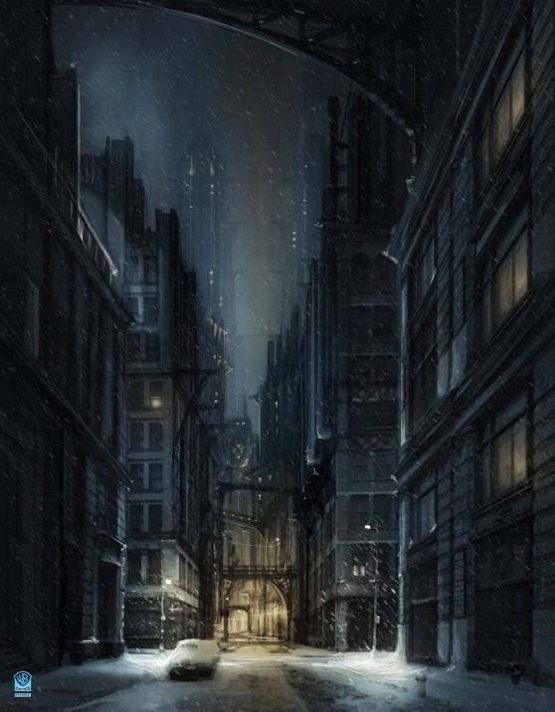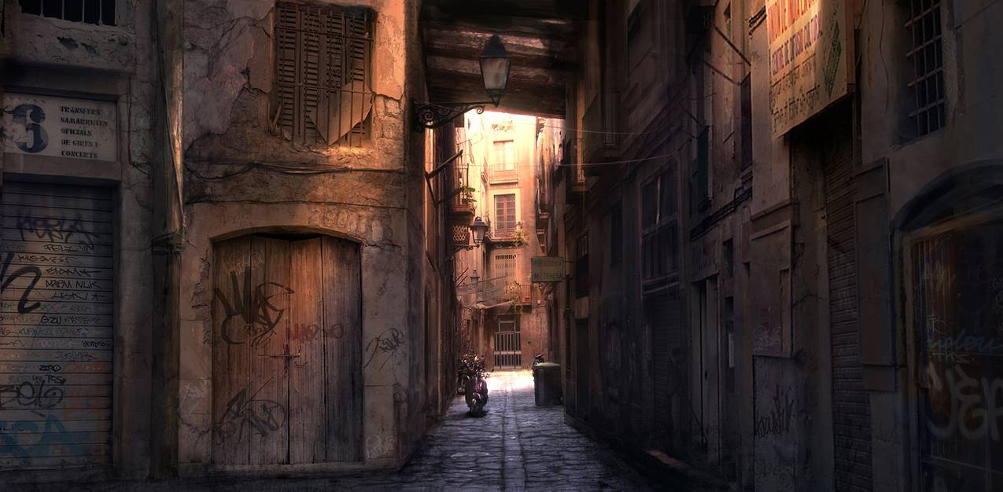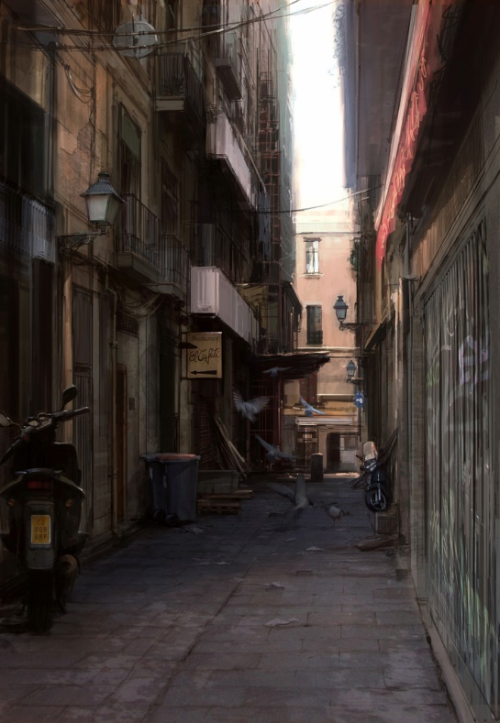

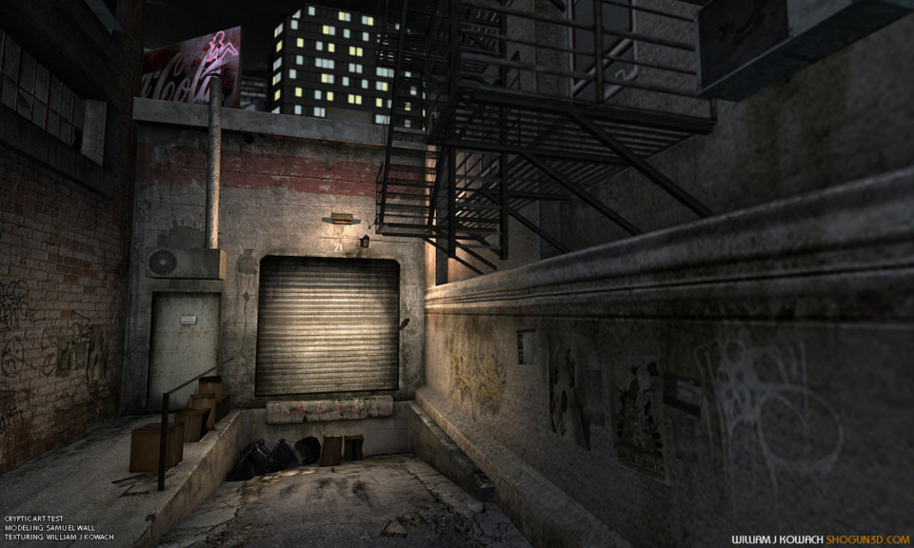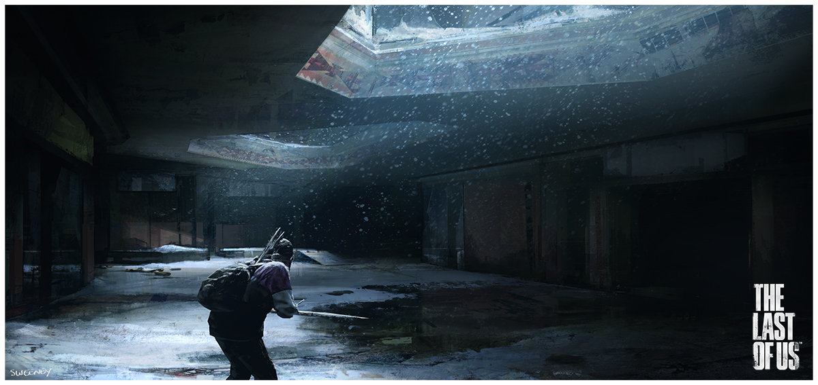

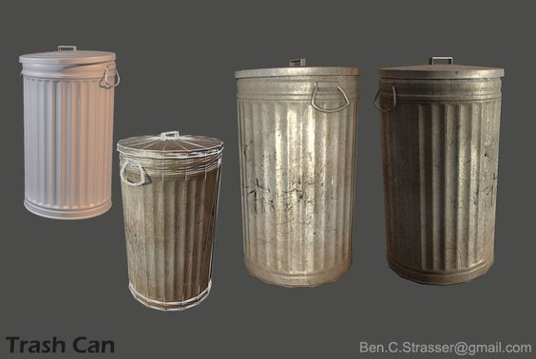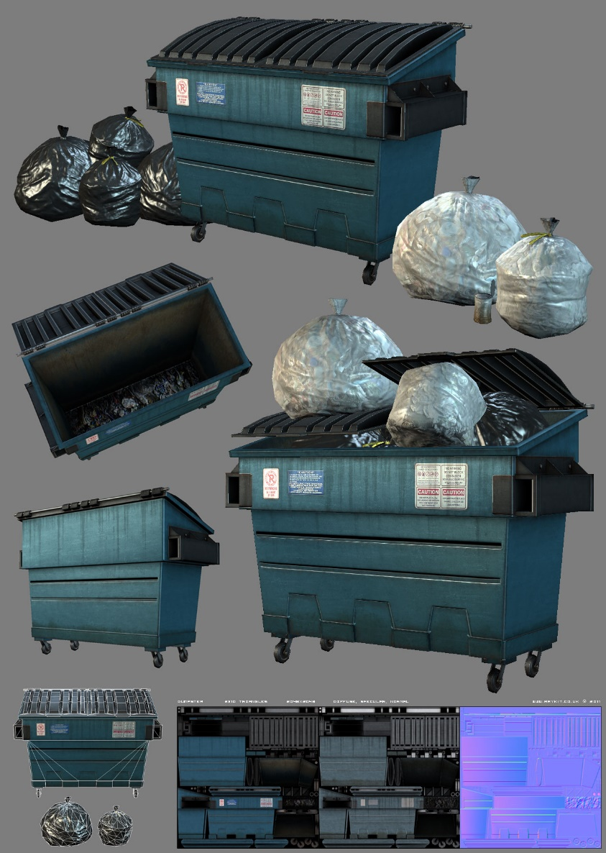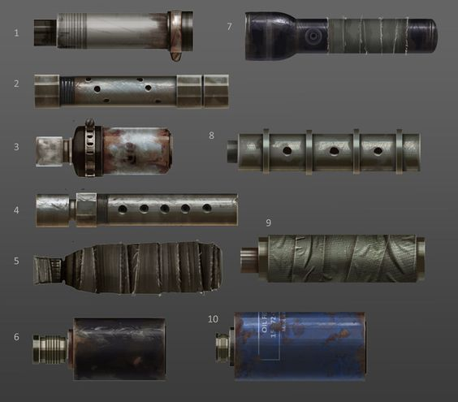

**Mechanics:**

Player:

* Crouch/Sneak
* Attack
  + Upfront
  + Sneak attack
  + Throw Items
* Sprint (Stamina Meter?)
* Pick up weapons
* Jump?
* Take Damage from:
  + Cold
  + Enemies
* Heal (from first aid kits)?

Enemy:

* Patrol
* Attack if sees player
* Notice fellow injured enemies and get distracted
* Get Distracted by noise from objects

Person To Rescue:

* Follow Player
* Attempt to avoid enemies?

Environment

* Random Spawning of Items?

**Visual Effects:**

Environment:

* Snow Falling
* Footsteps in Snow
  + Appearing and Disappearing
* Flickering Lights
* Fog
* Trash Fire

People:

* Breath

Other:

* Breaking of weapons